# CS 310 Changelog

All notable changes made from the tutorial exercises for CS 310 using the Calculator application will be documented in this file. Each version will match to a separate tutorial. Remember to start at the end of this file and work your way up. The most recent change will be located at the top of this document.

## Version 12.0.0 <2021-06-11>

Note: Jukebox Playlist Application

Major Changes:

* Added BrandonRicks to playlists

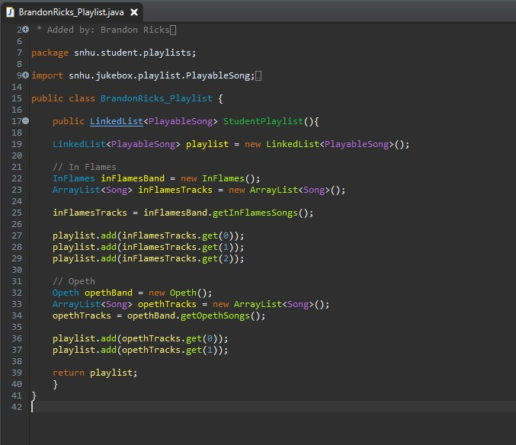

* Added case statement for profile in StudentList
* Updated unit test to StudentTest to include profile tests
* Created pull request for merge

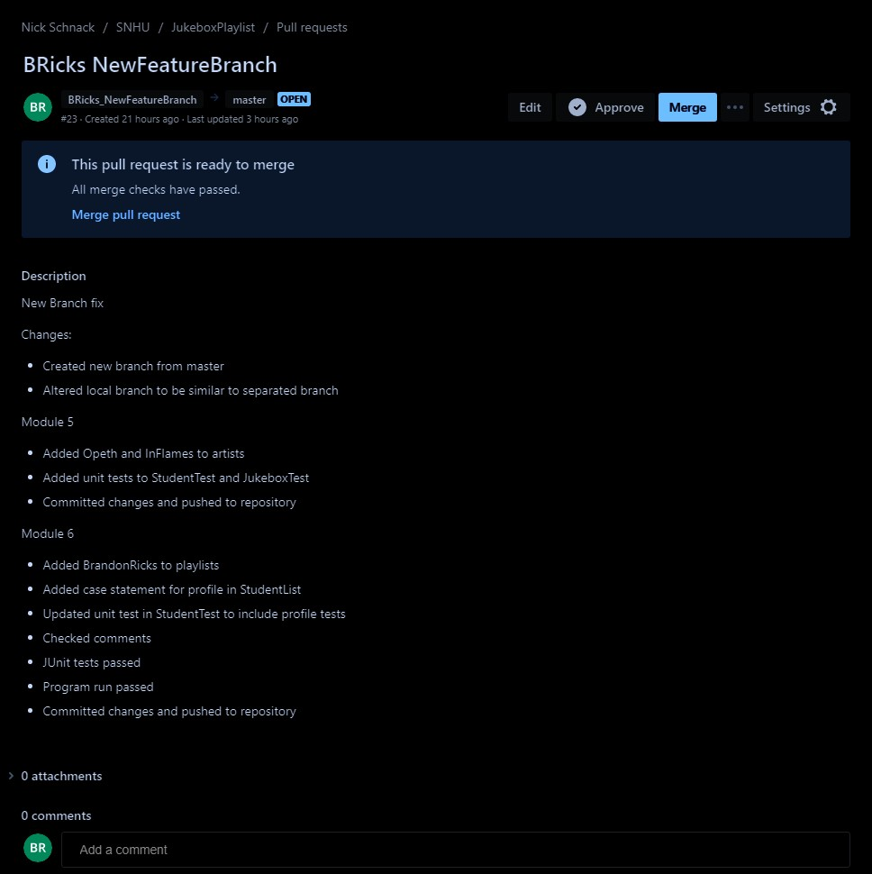

Minor Changes:

* Ran JUnit tests: passed
* Ran program to test functionality: program ran successfully

Bug Fixes:

* Fixed issue with branch in repository being detached

## Version 11.0.0 <2021-06-04>

Note: Jukebox Playlist Application

Major Changes:

* Created a feature branch for Jukebox Playlist app
* Added InFlames and Opeth to artists

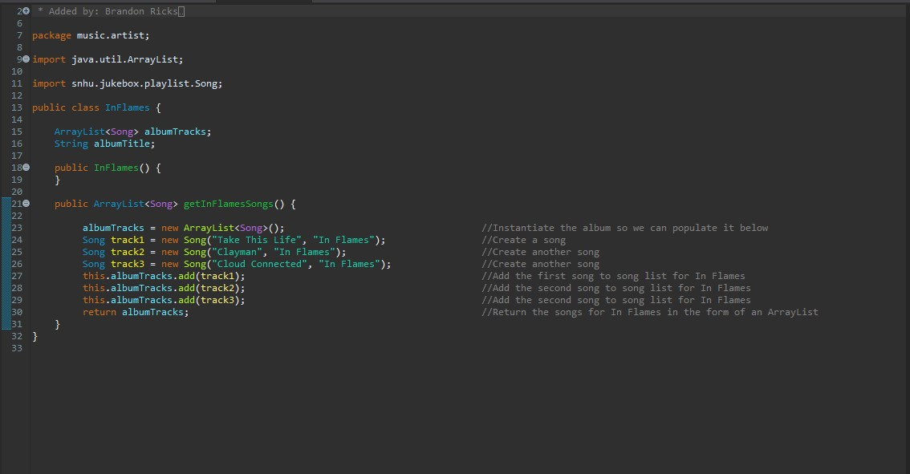

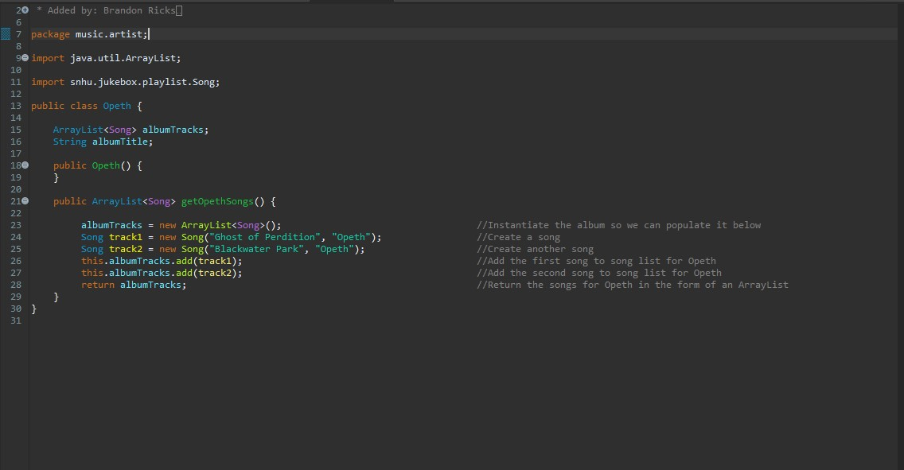

Minor Changes:

* Modified tests for StudentTest and JukeboxTest

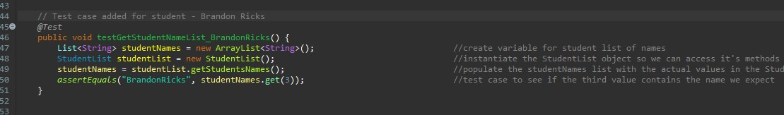

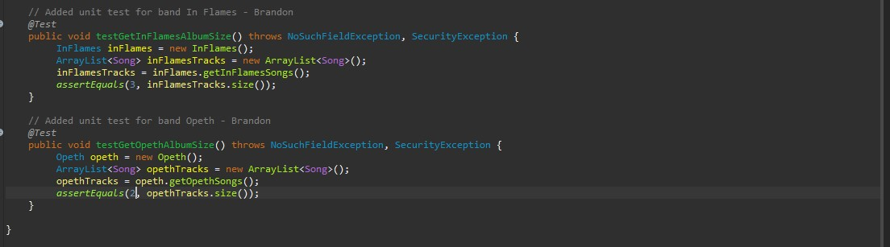

* Added comments to new code
* Committed and Pushed changes of new branch titled “Bricks_FeatureBranch” to remote repository on BitBucket

Bug Fixes:

* Not Applicable

## Version 10.0.0 <2021-05-29>

Note: Tutorial Ten: Stashing Changes in EGit

Major Changes:

* Added “@since 1.0” to BinaryOperation.java and stashed this change.

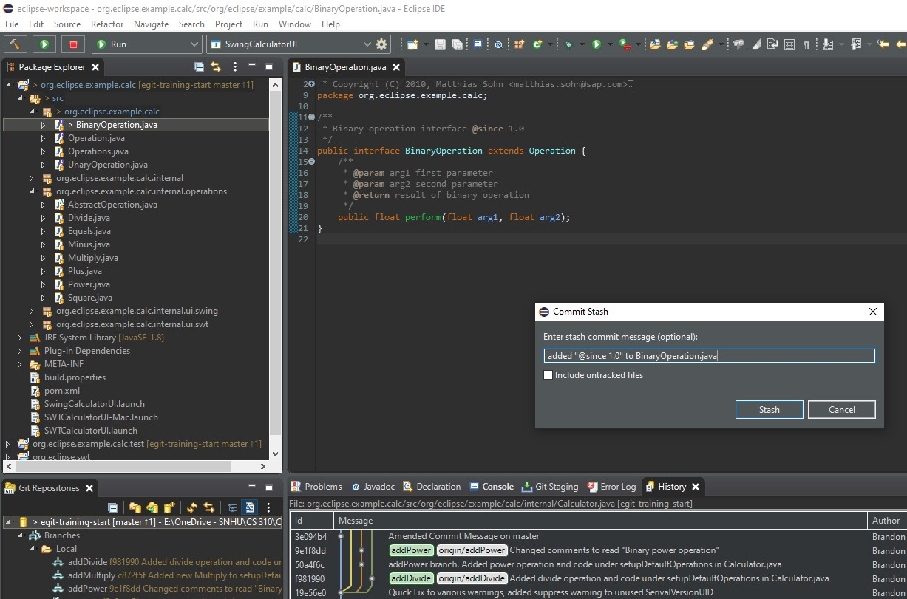

* Applied the stashed changes to the javadoc branch.

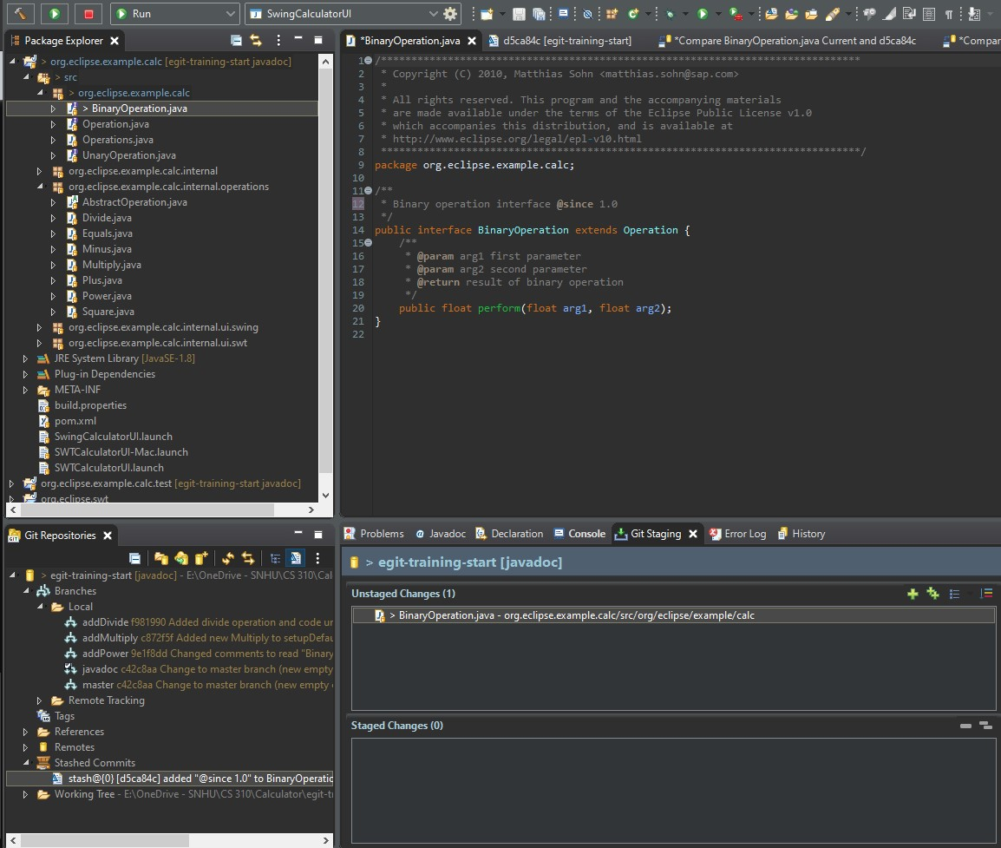

Minor Changes:

* Compared the working tree with the stashed changes.

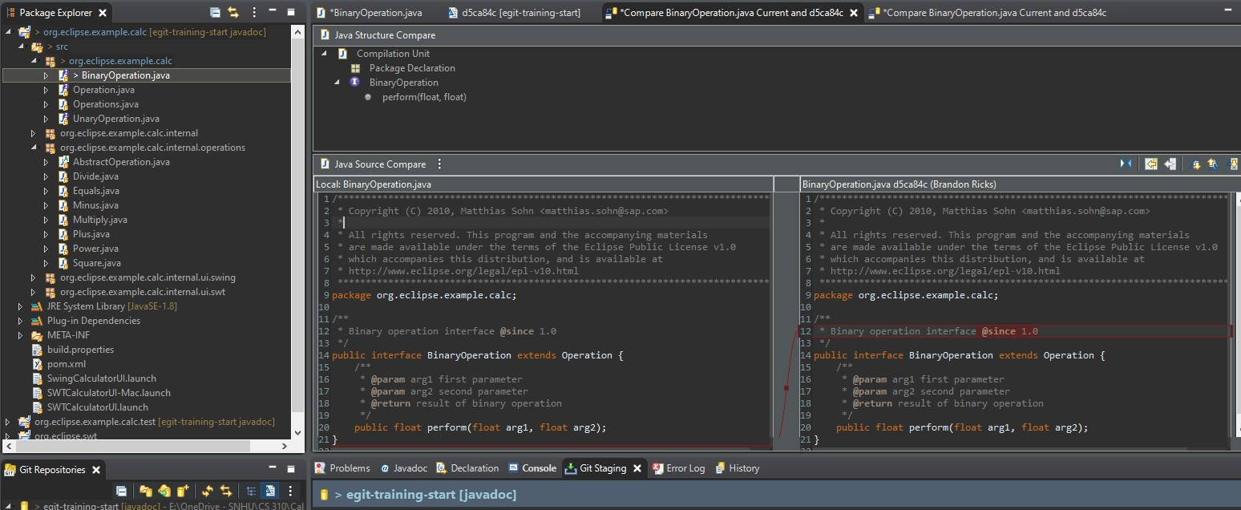

Bug Fixes:

* Not Applicable

## Version 9.0.0 <2021-05-29>

Note: Tutorial Nine: Use the “Git Blame” Feature

Major Changes:

* Opened Calculator.java and used the “show revision information” option to show commit information and author.

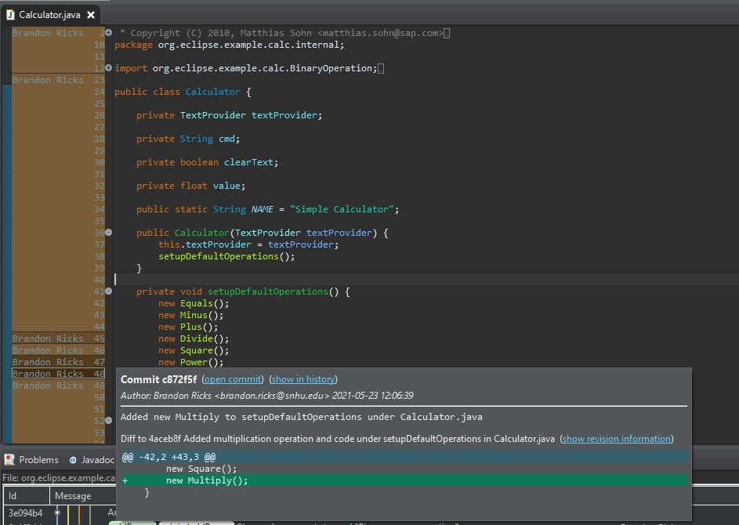

* This information is also shown within the History tab.

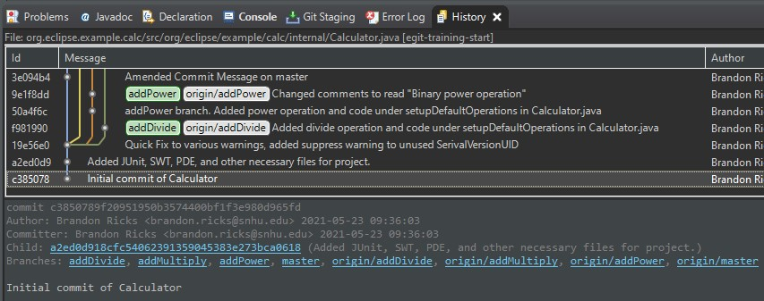

Minor Changes:

* Reverted to before new branch was created for tutorial 8.

Bug Fixes:

* Not Applicable

## Version 8.0.0 <2021-05-29>

Note: Tutorial Eight: Change a Series of Commits

Major Changes:

* Created a separate branch for the tutorial with an empty class file, and added a different empty class file to the master branch to create differences in the branches.

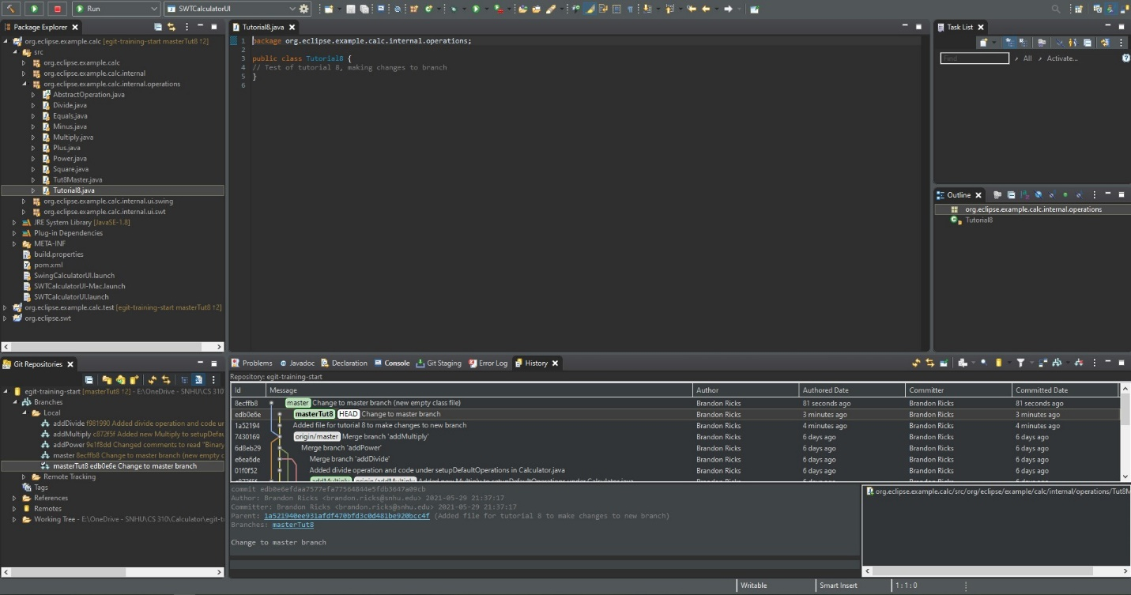

* Cherry-picked the other commit to add the difference between them to the new commit.

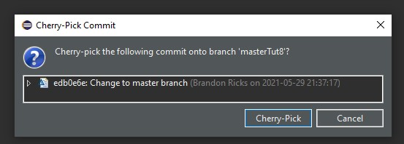

Minor Changes:

* Not Applicable

Bug Fixes:

* Issues with SWT not being included in project, needed to import

## Version 7.0.0 <2021-05-23>

Note: Tutorial Seven: Reset Branch to a Previous State

Major Changes:

* Applied reset mixed to addDivide, resetting the branch pointer.

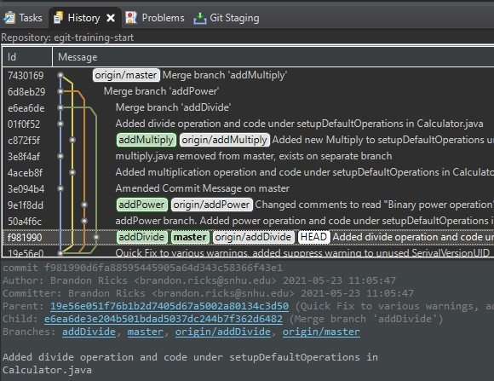

* Amended commit and reset branch.

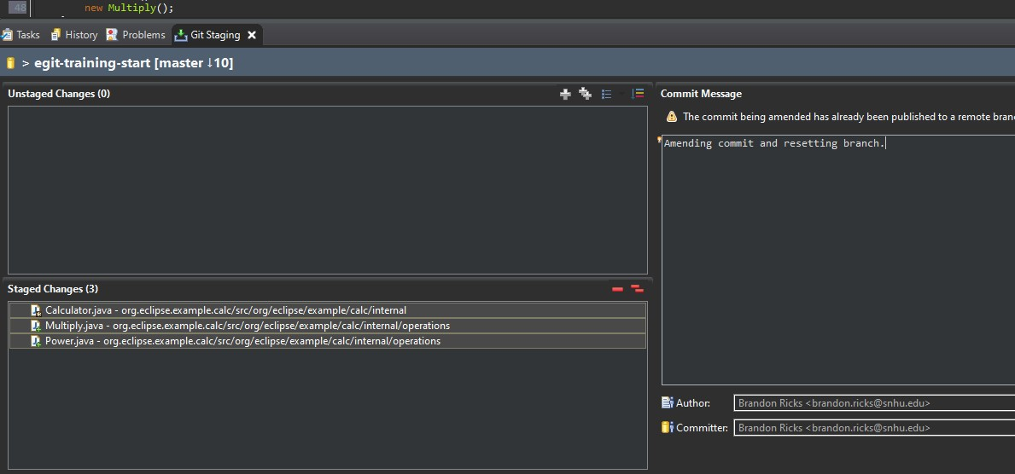

Minor Changes:

* Branch reset create a new master separate from prior mergers.

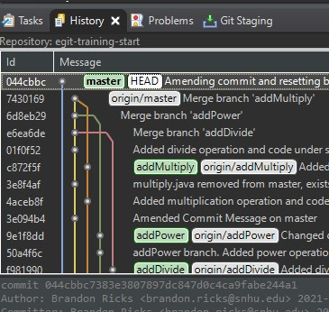

* Reset back before amend to prior tree.

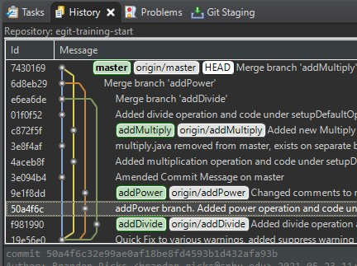

Bug Fixes:

* Not Applicable

## Version 6.0.0 <2021-05-23>

Note: Tutorial Six: Merging, Rebasing, and Resolving Conflict

Major Changes:

* Began merging all branches together. addDivide and addPower merged successfully

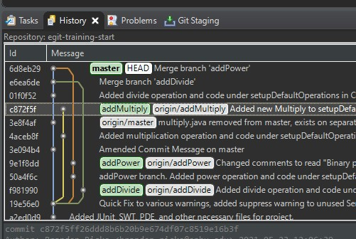

* addMultiply conflicted. Used merge tool to merge and fix conflict, added newly resolved file to index.

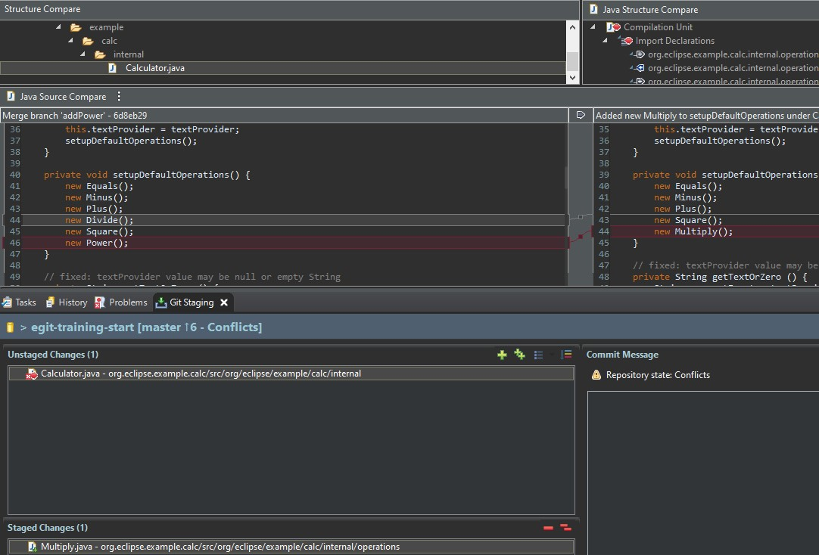

Minor Changes:

* Confirmed in History tab that all mergers were successful.

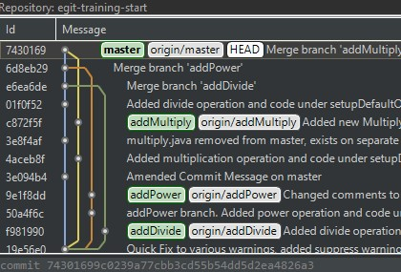

* Tested all functions in calculator to ensure newest branch works as intended prior to push.

Bug Fixes:

* addMultiply conflict was fixed and added to index.

## Version 5.0.0 <2021-05-23>

Note: Tutorial Five: Fetch the Latest State From Upstream

Major Changes:

* Attempted Fetch from origin; everything is up to date

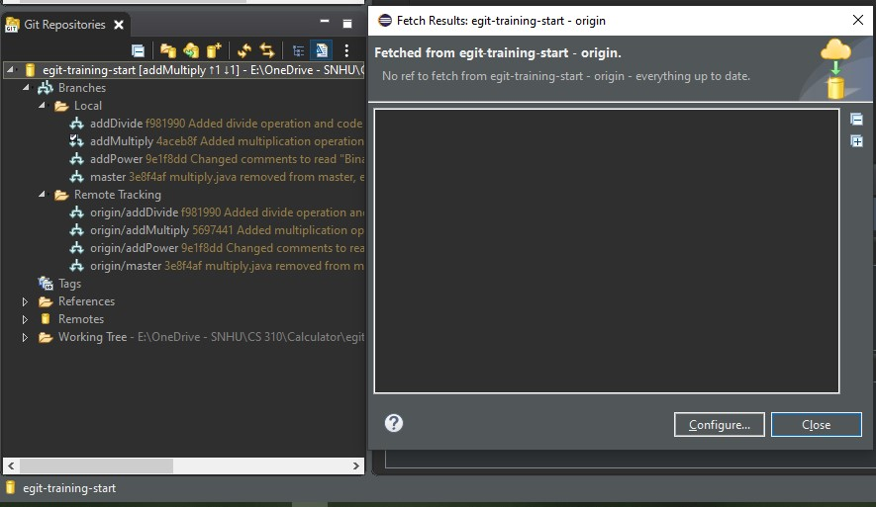

* As everything is up to date, this is a good foundation to create new local feature branches

Minor Changes:

* Not Applicable

Bug Fixes:

* Not Applicable

## Version 4.0.0 <2021-05-23>

Note: Tutorial Four: Work on Branches in Parallel

Major Changes:

* Created a new feature: addMultiply

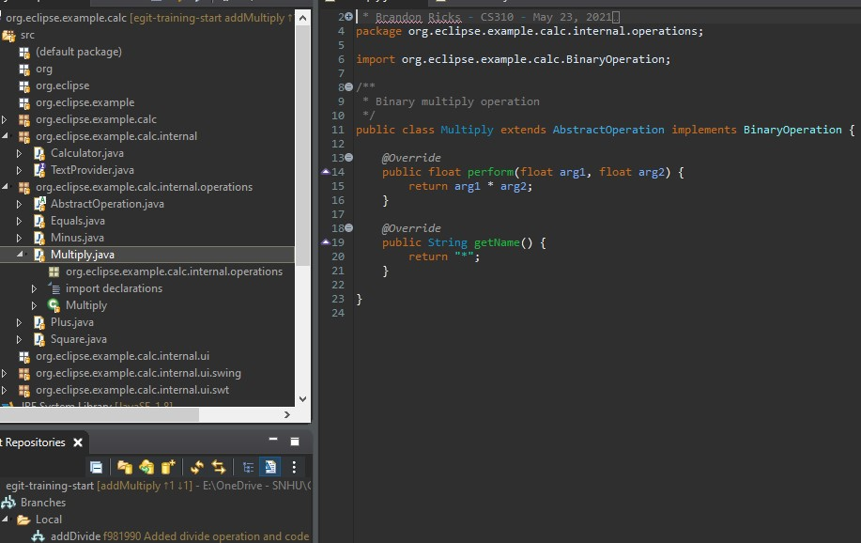

* Changed committed comments using Amend

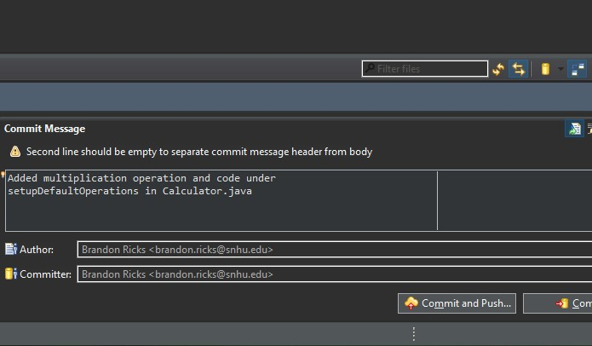

Minor Changes:

* Updated Calculator.java to make use of new Multiply.java
* Did preliminary commit of new addMultiply branch

Bug Fixes:

* Amended master branch comments
* Cleaned up branches and commits

## Version 3.0.0 <2021-05-16>

Note: Tutorial Three: Inspecting the History

Major Changes:

* Inspected History View of repository
* Configured History View to show branching of Divide

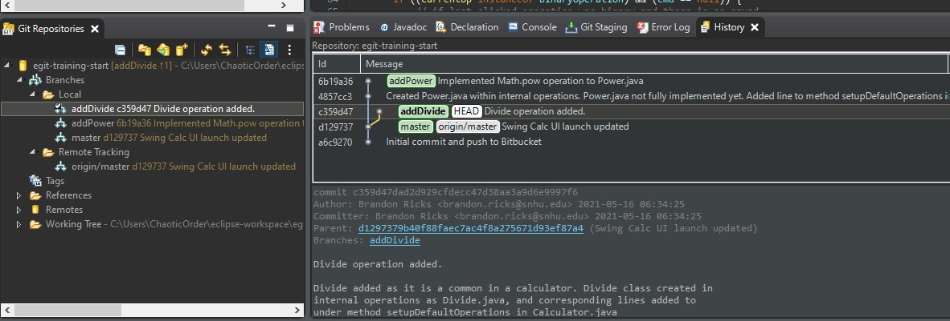

Minor Changes:

* Attempted commit search
* Pushed Divide branch to bitbucket repository master

Bug Fixes:

* Changed comment from "Binary plus operation" to "Binary divide operation"

## Version 2.0.0 <2021-05-16>

Note: Tutorial Two: Develop Another Feature and Use Staging View

Major Changes:

* Developed a new feature branch
* Created new feature Power (NOTE: Power not yet implemented into UI)

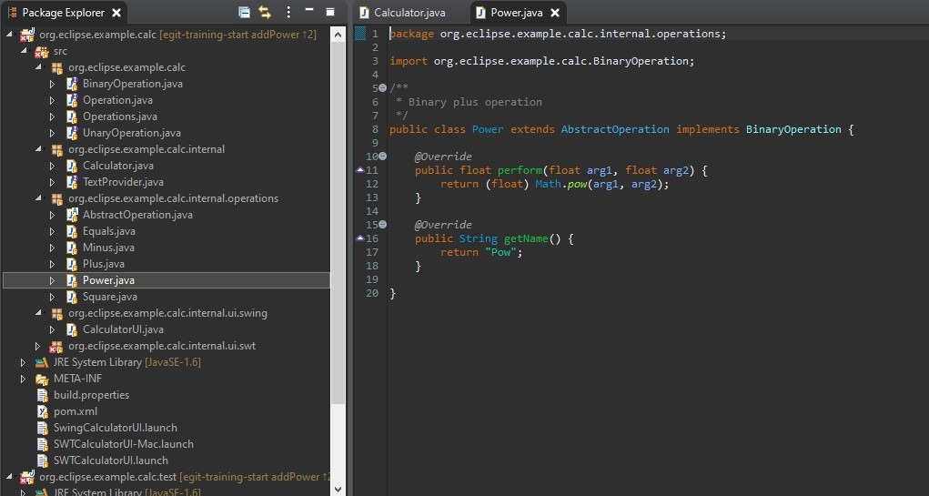

Minor Changes:

* Updated Calculator.java to make use of new Power.java
* Committed changes locally to Calculator.java and Divide.java in Git Staging

Bug Fixes:

* Not Applicable

## Version 1.0.0 <2021-05-16>

Note: Tutorial One: Develop a Feature Bug Fix

Major Changes:

* Created a new feature branch
* Created feature Divide

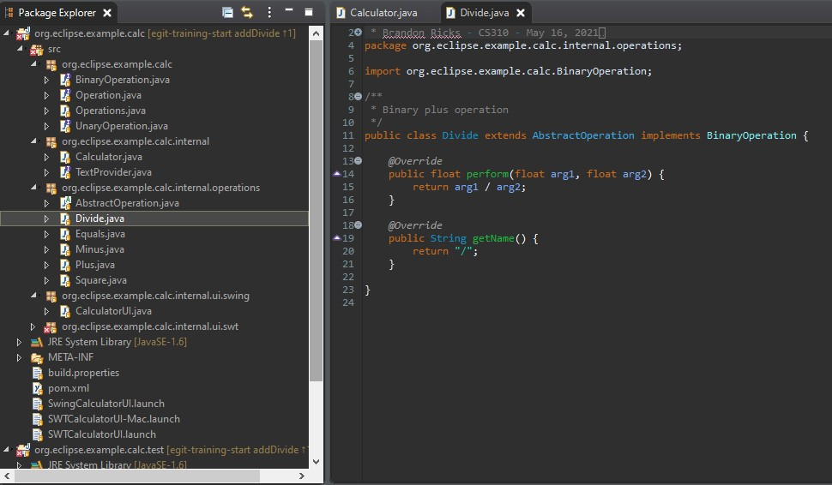

Minor Changes:

* Updated Calculator.java to make use of new Divide.java
* Committed changes locally to Calculator.java and Divide.java in Git Staging

Bug Fixes:

* Not Applicable